BSSE23058 Zunaira Abdul Aziz
BSSE23026 Eashal Yasin
BSSE23003 Fatima Noorulain
Assignment # 1
33. PSO
https://dps.psx.com.pk/company/PSO

Task (a)
- Business Case & Financial Evaluation:
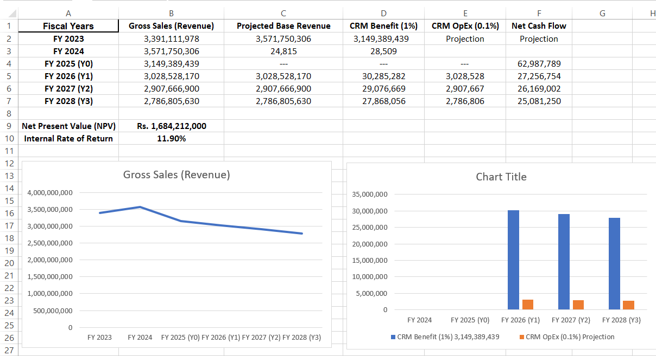
- Risk Identification & Assessment:
 | Risk Description | Occurrence Probability | Impact | Mitigation Strategy (Optional but recommended)
1 | Data Integration Complexity: Difficulty syncing the new CRM with PSO’s existing legacy ERP and SAP systems across 3,500+ outlets. | High | High | Phase the rollout by region (e.g., Karachi first) to test integration.
2 | Low Adoption by Station Staff: Front-end fuel station staff may find it difficult or time-consuming to input customer data (DigiCash/Loyalty) during peak hours. | High | Medium | Provide simplified mobile interfaces and incentives for staff who hit data entry targets.
3 | Data Privacy & Cybersecurity: Risk of customer personal data or transaction history being leaked, leading to legal penalties from regulators. | Low | Critical | Implement end-to-end encryption and conduct regular third-party security audits.
4 | Inaccurate Linear Projections: If fuel prices fluctuate wildly or the economy slows, the "1% Revenue Increase" might not materialize as projected. | Medium | High | Perform quarterly reviews of the business case and adjust marketing spend accordingly.
5 | Connectivity Issues at Remote Sites: Many PSO stations are in rural areas with poor internet, preventing real-time CRM updates. | Medium | Medium | Use "Offline-First" application architecture that syncs data once a connection is restored.

Task (b)

Step 1: Identify Project Scope and Objectives
- 1.1 Identify Objectives: To implement a CRM system that increases customer retention and repeat fuel/lubricant sales by 1% through targeted loyalty programs (DigiCash) and fleet management.
- 1.2 Establish Project Authority: PSO’s IT Department and Retail Marketing Division.
- 1.3 Stakeholder Analysis (PSO Specific):
  - Internal: PSO Board of Management, IT Department (System Admins), Retail Marketing Team, Fuel Station Managers.
  - External: Retail Customers (Commuters), Corporate Fleet Owners (Logistics companies), SBP/Regulators (for financial data compliance).
- 1.4 Modify Objectives: Ensure the CRM can handle offline transactions at remote fuel stations in Balochistan or Northern areas.

Step 2: Identify Project Infrastructure
- 2.1 Project Standards: ISO 27001 for data security; Agile methodology for software development.
- 2.2 Identify Measurement Scales: Success is measured by the number of active loyalty cards and the "Repeat Purchase Rate."
- 2.3 Resource Categories: Hardware (Servers at PSO House), Software (CRM Licenses), Personnel (Database Engineers, Training Staff).

Step 3: Analyze Product Characteristics
- 3.1 Product Flow: Data flows from the Point of Sale (POS) at the fuel pump to the Central CRM Database at PSO HQ.
- 3.2 Product Categories:
  - System Products: Database, API for Mobile App, POS Integration Module.
  - Module Products: Loyalty Points Calculator, Fleet Customer Portal, Automated SMS/Email Marketing Engine.
  - Management Products: Project Plan, Risk Log, User Training Manuals, Final Completion Report.

Step 4: Analyze Products (The Diagrams)
- 4.1 Product Breakdown Structure (PBS)
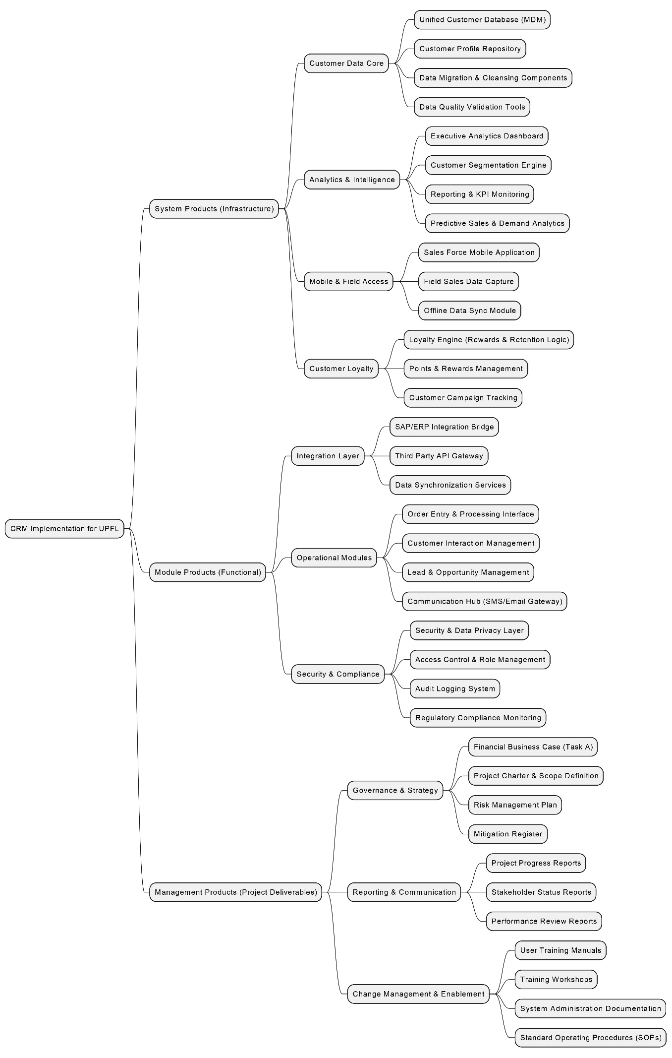
- 4.2 Product Flow Diagram (PFD)
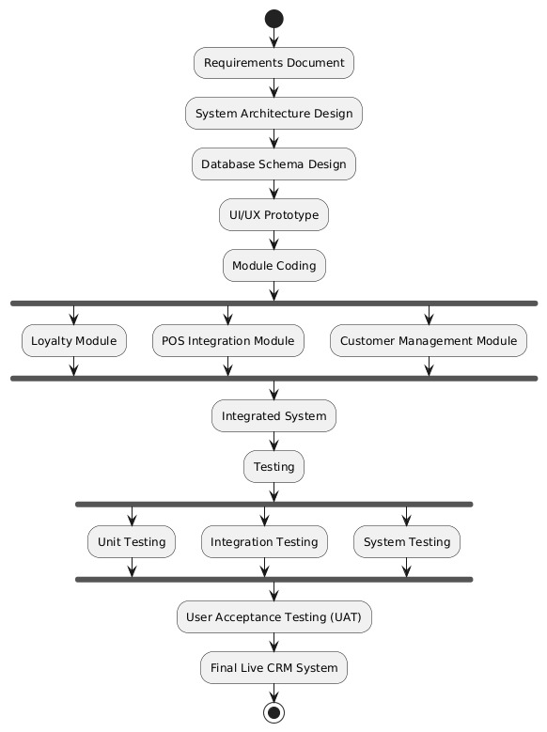

- 4.3 Ideal Activity Network

